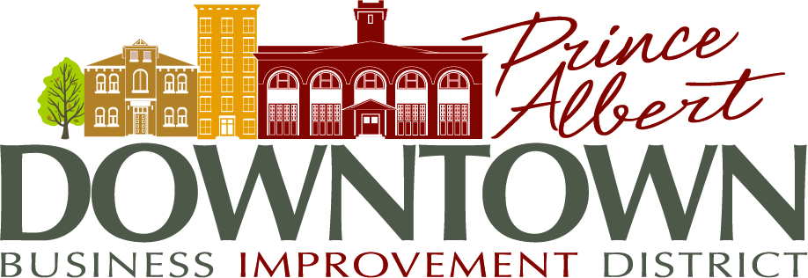

Minutes

September 8th, 2021
Email vote

Bylaw No. 4 of 2005 states the Statutory Board PURPOSE is:

The purpose or mandate of the business improvement district is to encourage the development of a vibrant and prosperous downtown business district by improving the area’s appearance and image, promoting and marketing the area, and undertaking initiatives and projects that facilitate the ongoing rejuvenation and redevelopment of the area.

PRESENT: Meghan Mayer, Carolyn Carleton, Brent MacDonald, Stacy Coburn, Dawn Kilmer, Philip Fourie

Motion: That the PADBID budget for 2022 be approved and forwarded to City Council for final approval.
.
Moved by: Stacy Coburn Seconded by: Meghan Mayer
*carried

__________________________________________ _________________________________________
Chair: Stacy Coburn Recording Sect.: Carolyn Carleton

